Problem | Page no
Find the duplicate number | 1
Sort 0 1 and 2’s | 1
Maximum sum subarray | 2
Merge Intervals | 2
Pascal’s Triangle | 3
Next permutation | 3
TREES
Tree BFS traversal | 4
DFS preorder traversal | 4
DFS inorder traversal | 5
DFS PostOrder traversal | 5
Maximum depth of a binary tree | 6
Balanced binary tree | 6
Diameter of a BT | 7
Maximum path sum in a BT | 7
Binary Tree Zigzag Level Order Traversal | 8
Binary Tree Right Side View | 8
Symmetric Tree | 9
LINKED LISTS
Add two numbers | 9

Find the duplicate number
Brute force: tc: O(NlogN), sc: O(1)
Better approach: tc: O(N), sc: O(N)
Optimal approach: tc: O(N), sc: O(1)

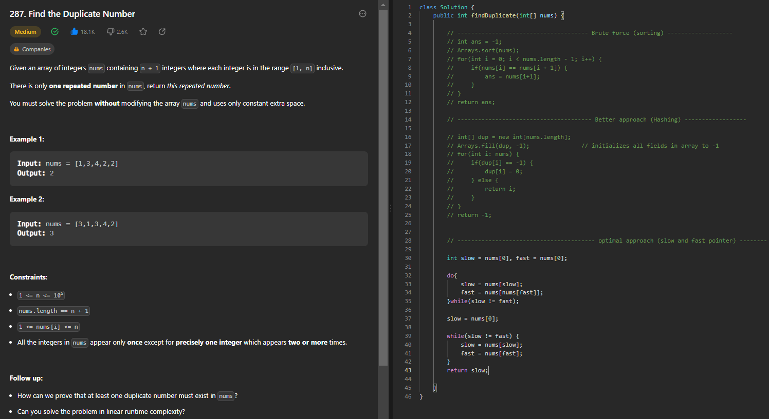

Sort 0 1 and 2’s
Brute force: tc: O(NlogN), sc: O(1)
Better approach: tc: O(N + N), sc: O(1)
Optimal approach: tc: O(N), sc: O(1)
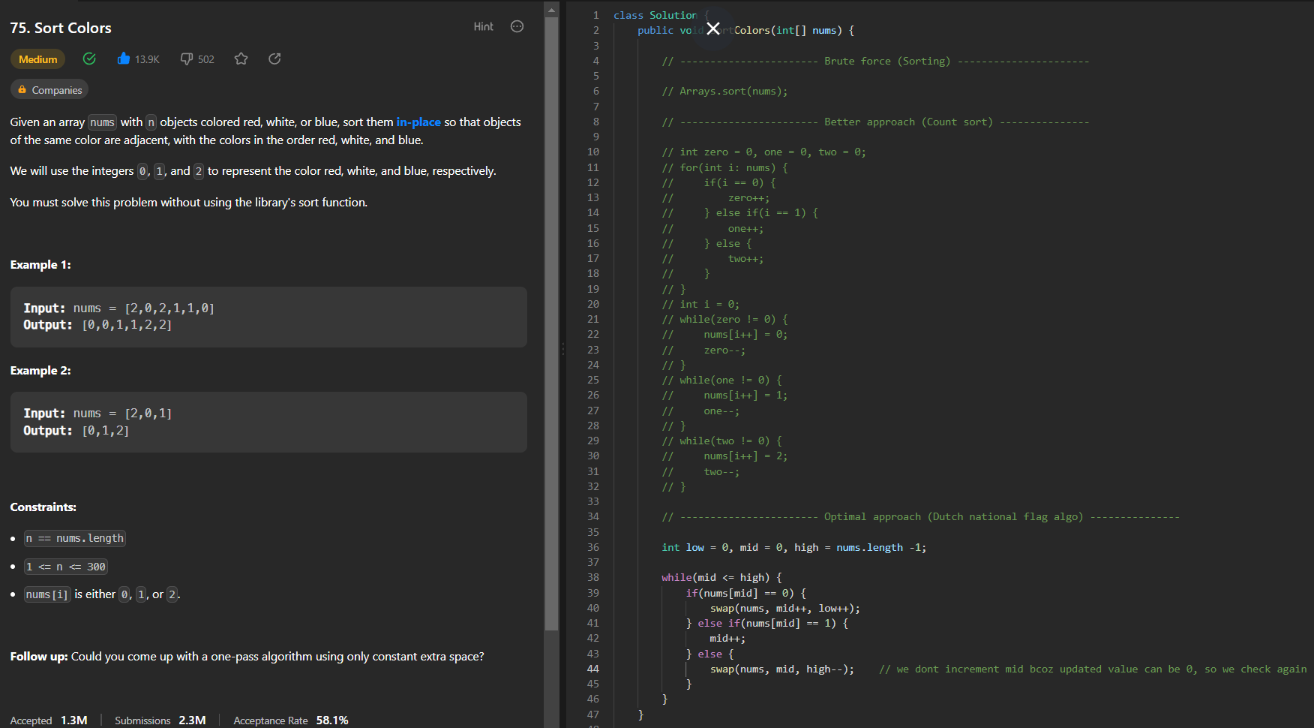
Maximum sum subarray
Brute force: tc: O(N^3), sc: O(1)
Better approach: tc: O(N^2), sc: O(1)
Optimal approach: tc: O(N), sc: O(1)

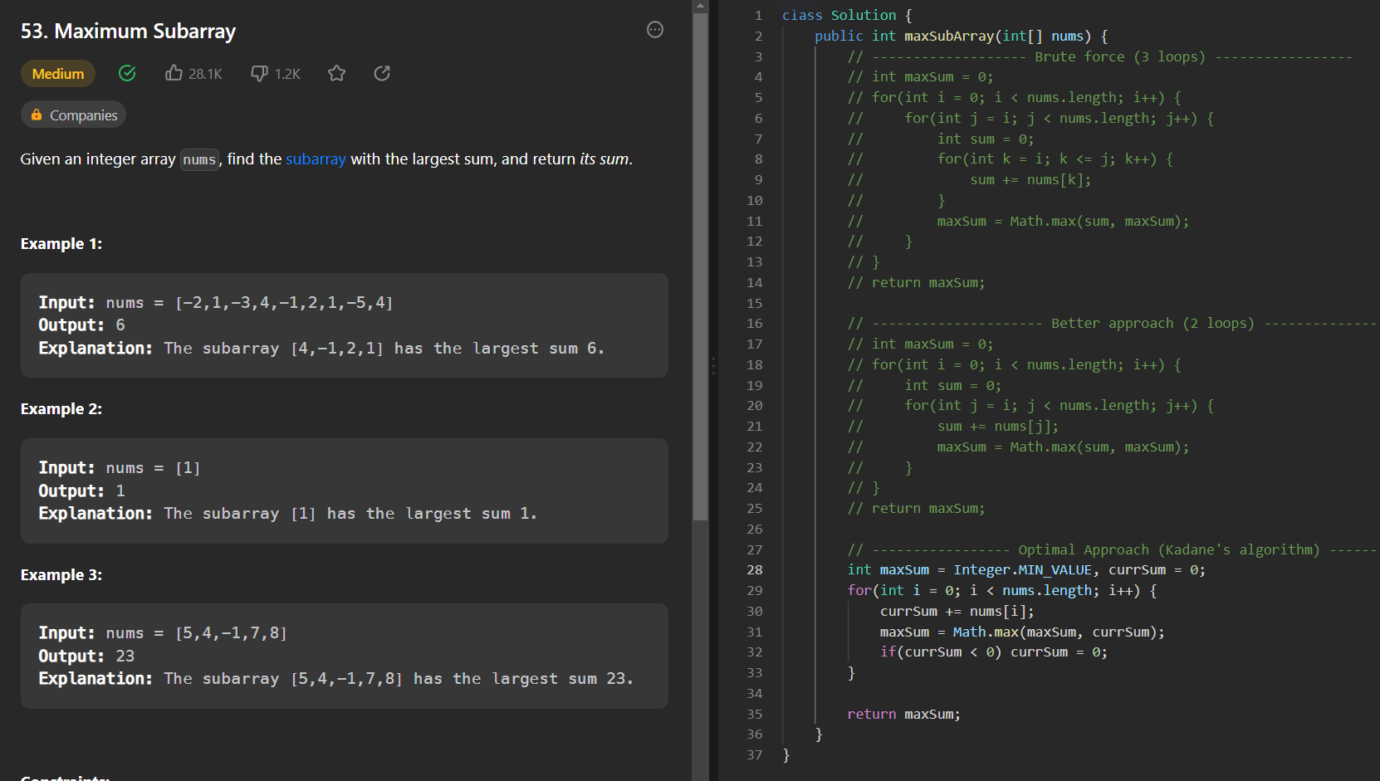

Merge Intervals
Approach 1: tc: O(NlogN), sc: O(1) if we ignore ans array space, if not it is O(N)
Approach 2: tc: O(NlogN), sc: O(1) if we ignore ans array space, if not it is O(N)

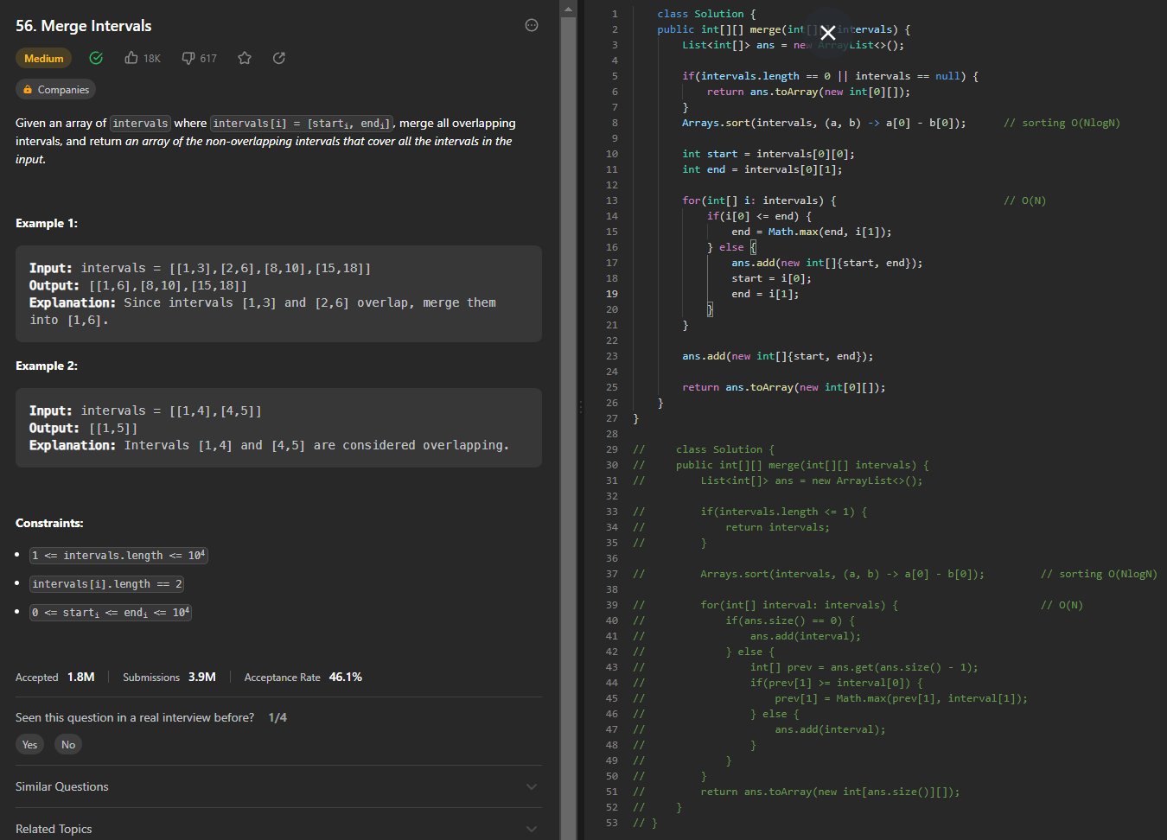

Pascal’s triangle
Tc: O(n * n)
Sc: O(n * n)

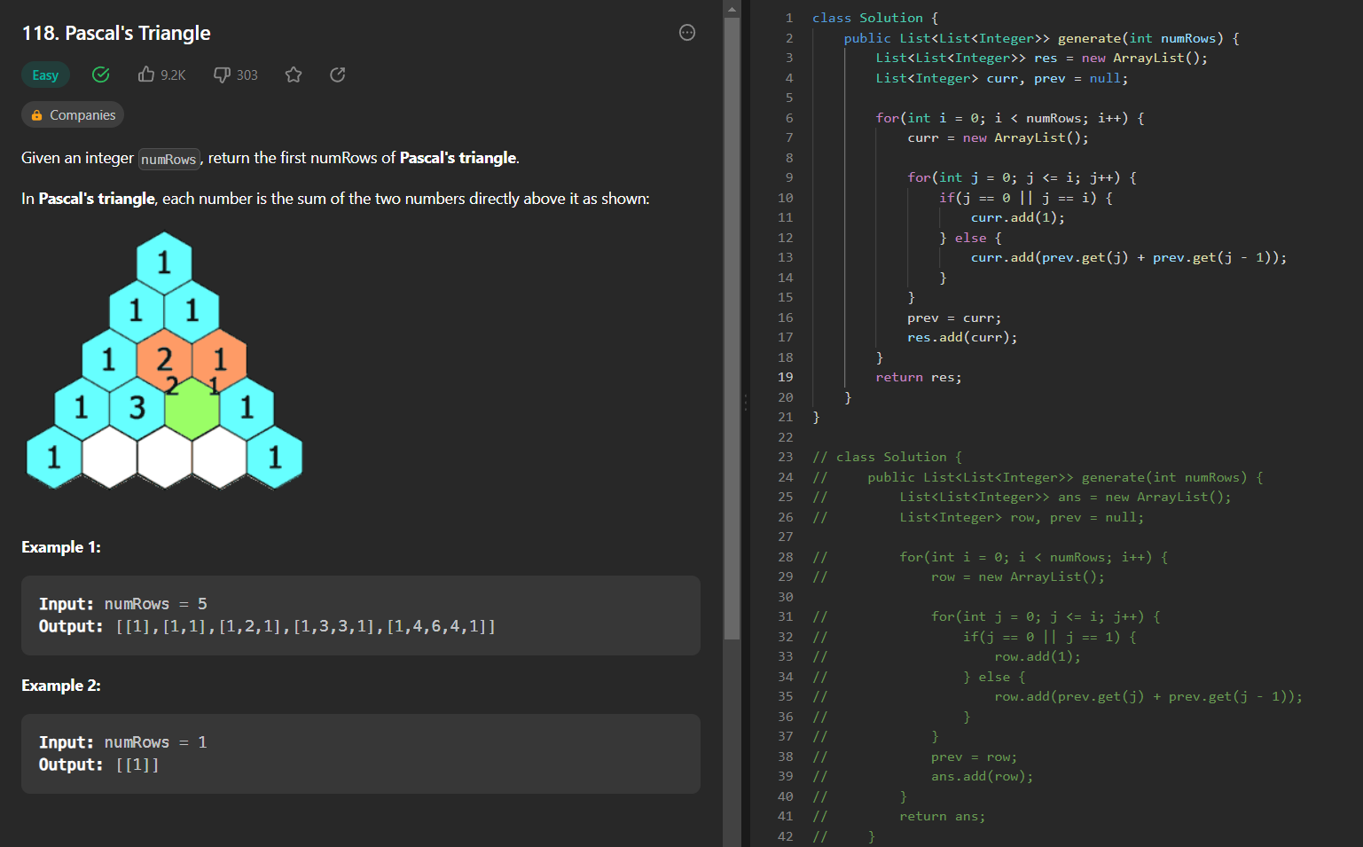

Next permutation
Tc: O(n * n * n) => O(n)
Sc: O(1)

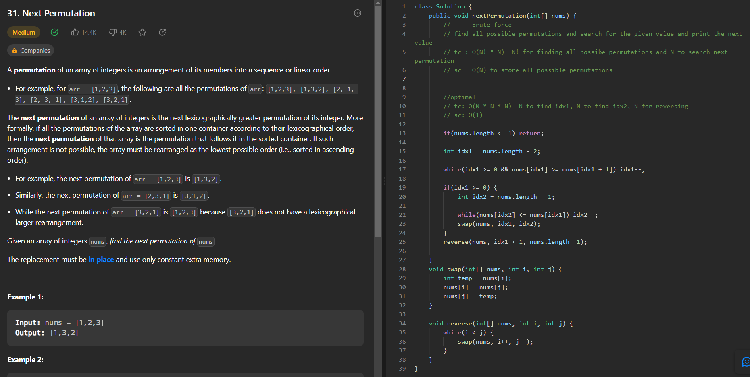
Tree BFS traversal
Iterative TC: O(n) recursive TC: O(n)
Sc: O(n) uses queue SC: O(1)

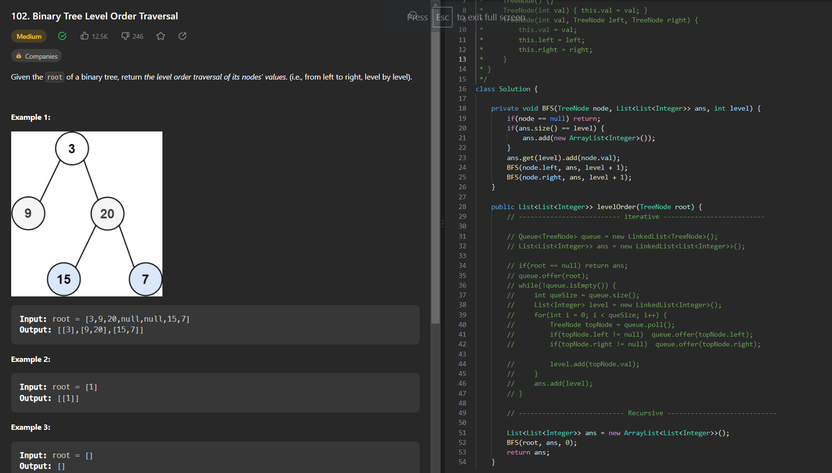

PreOrder traversal

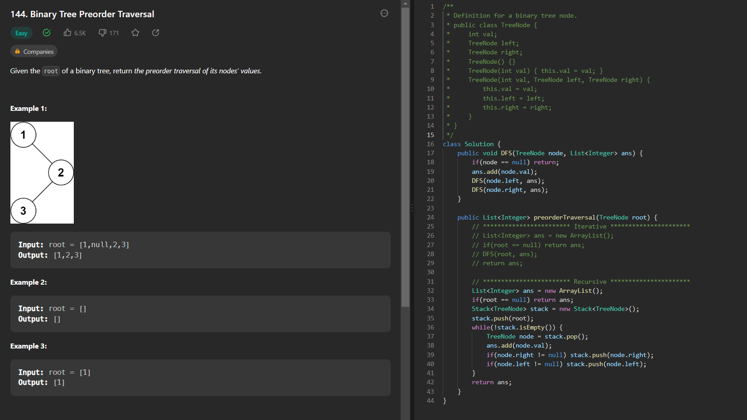

InOrder traversal

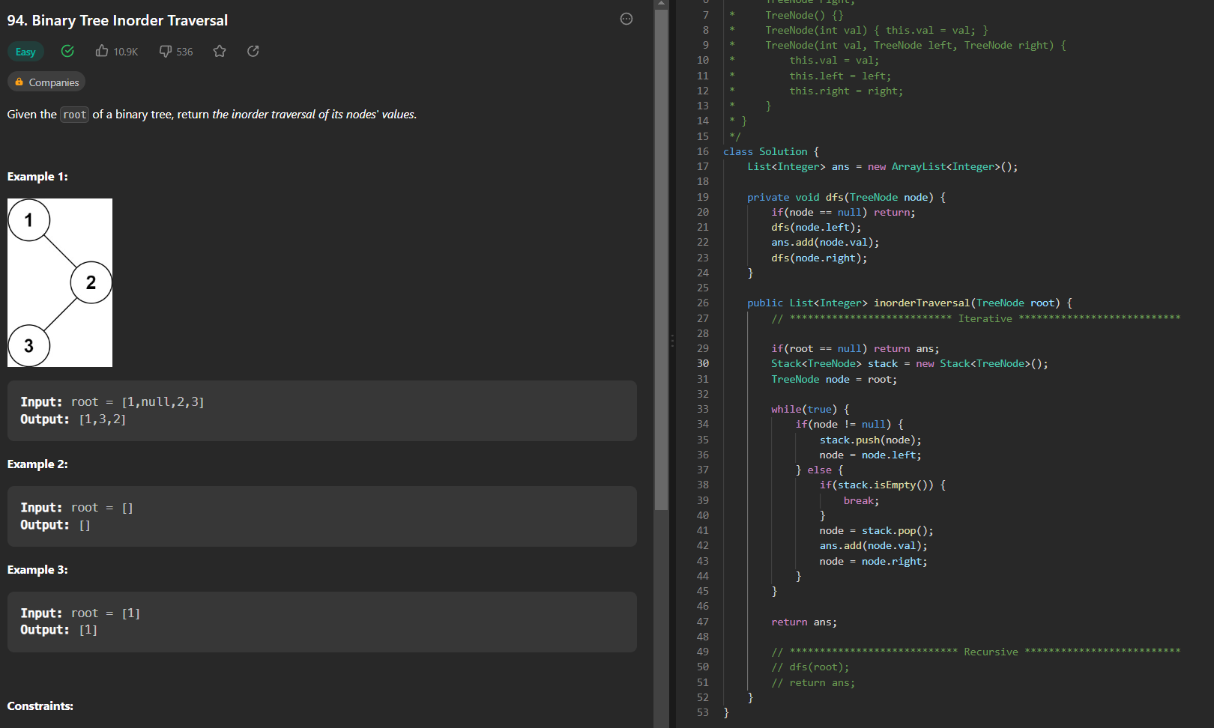

PostOrder traversal

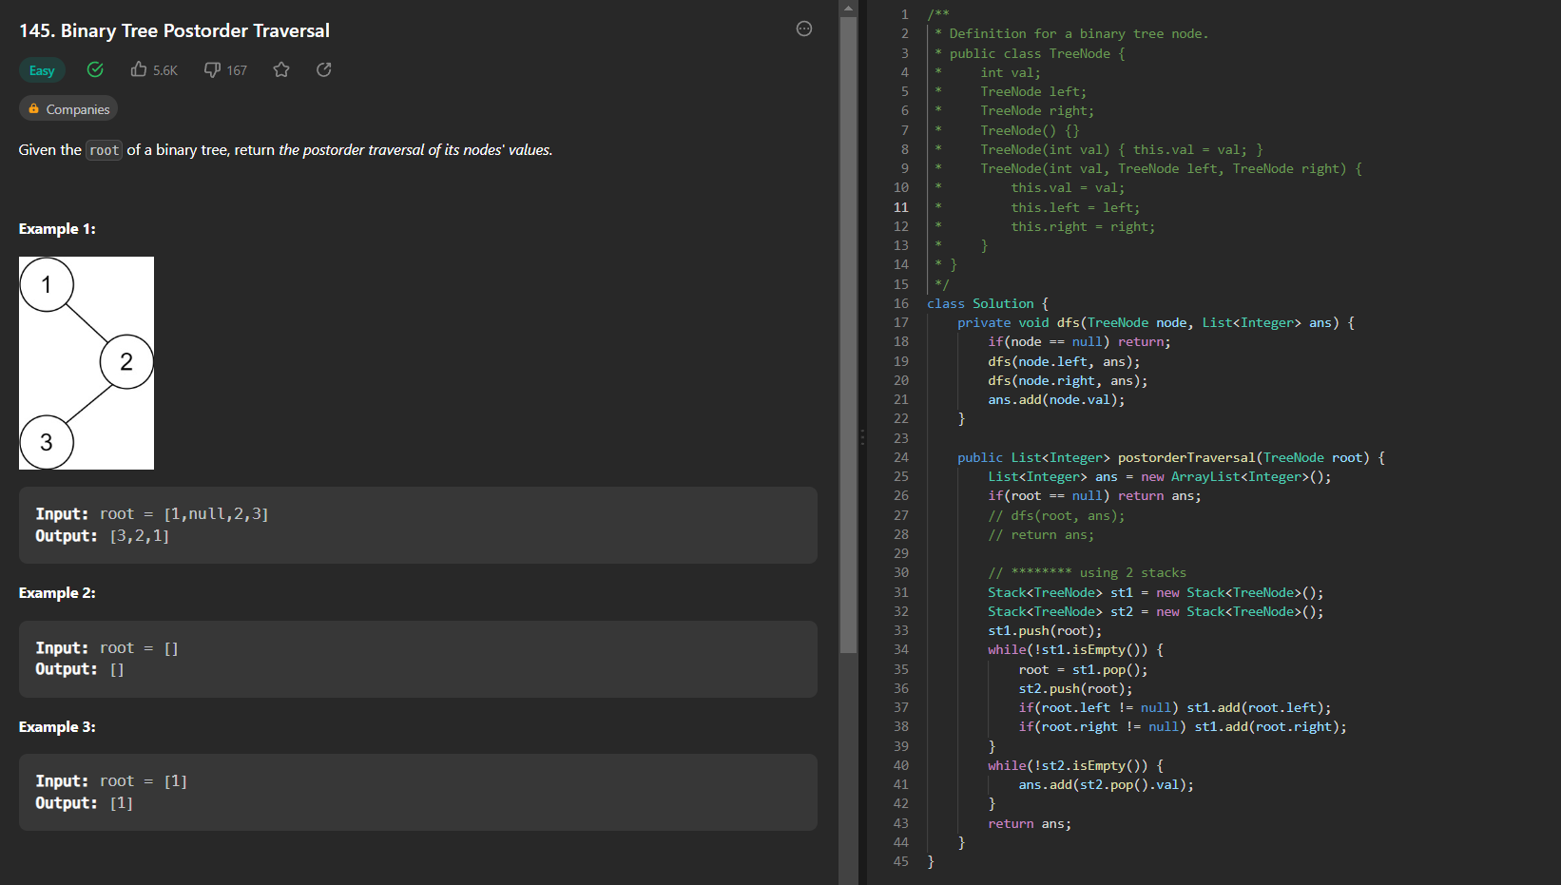
Maximum depth of the binary tree

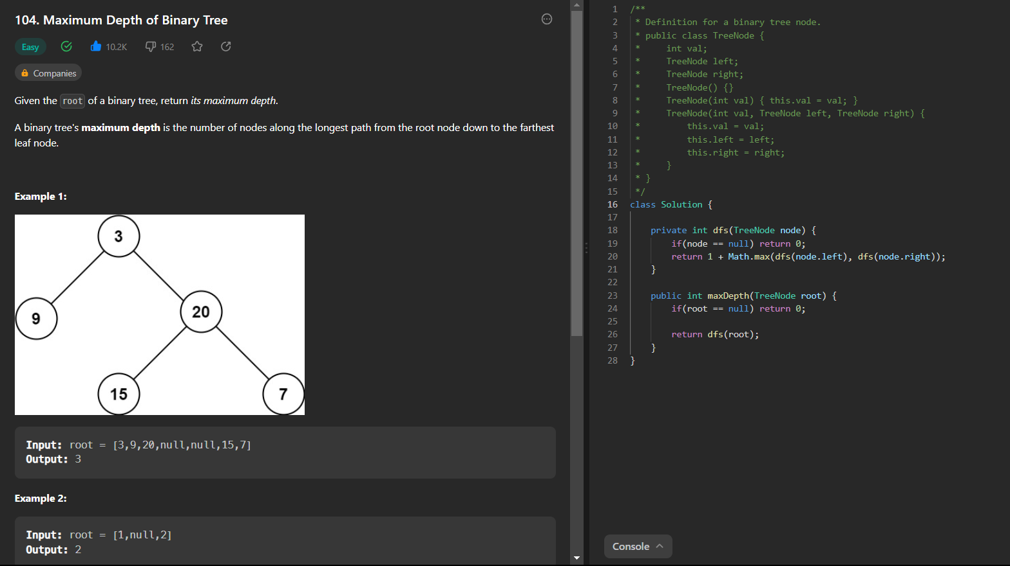

Balanced binary tree

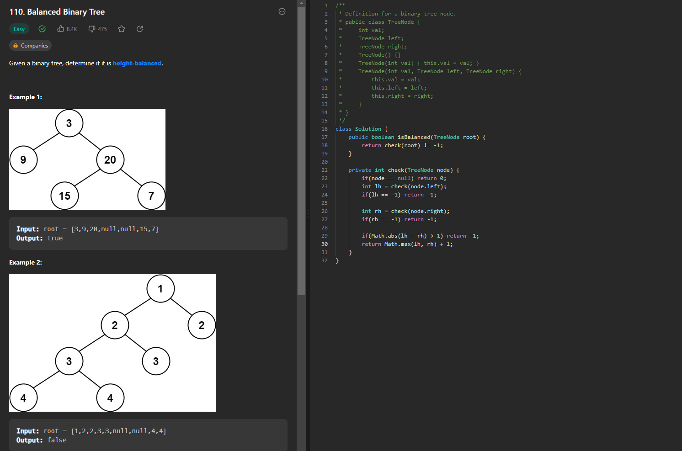
Diameter of Binary tree:

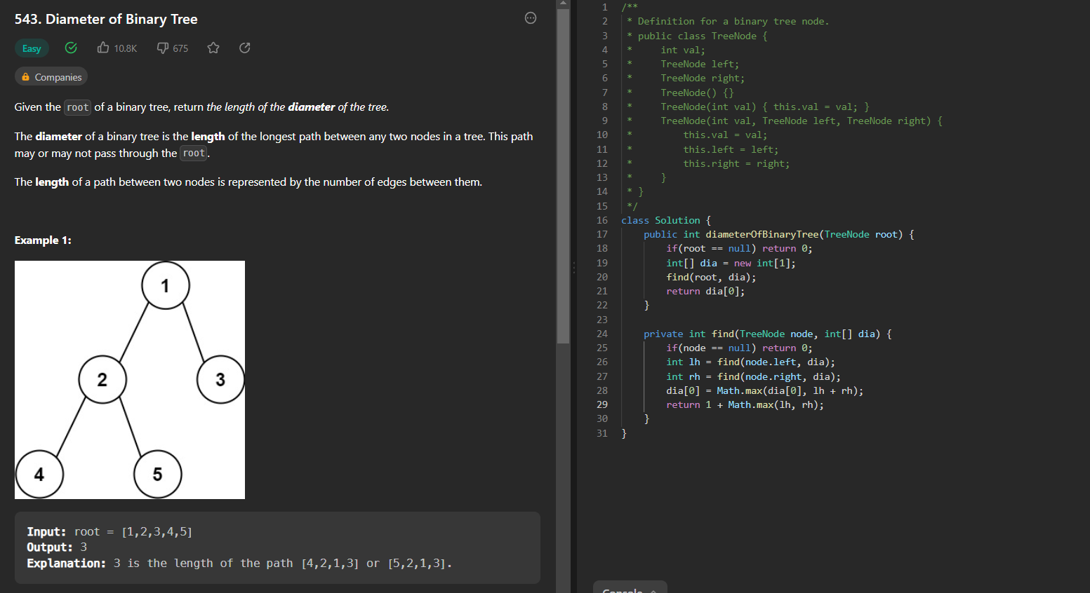

Maximum Path sum in a binary tree:

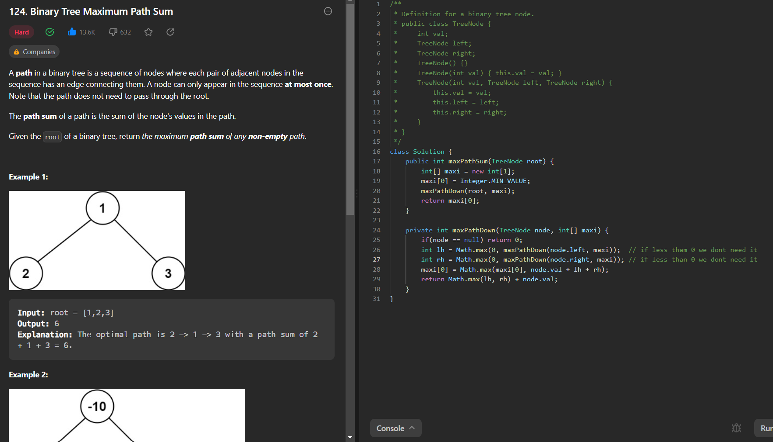
Binary Tree Zigzag Level Order Traversal:

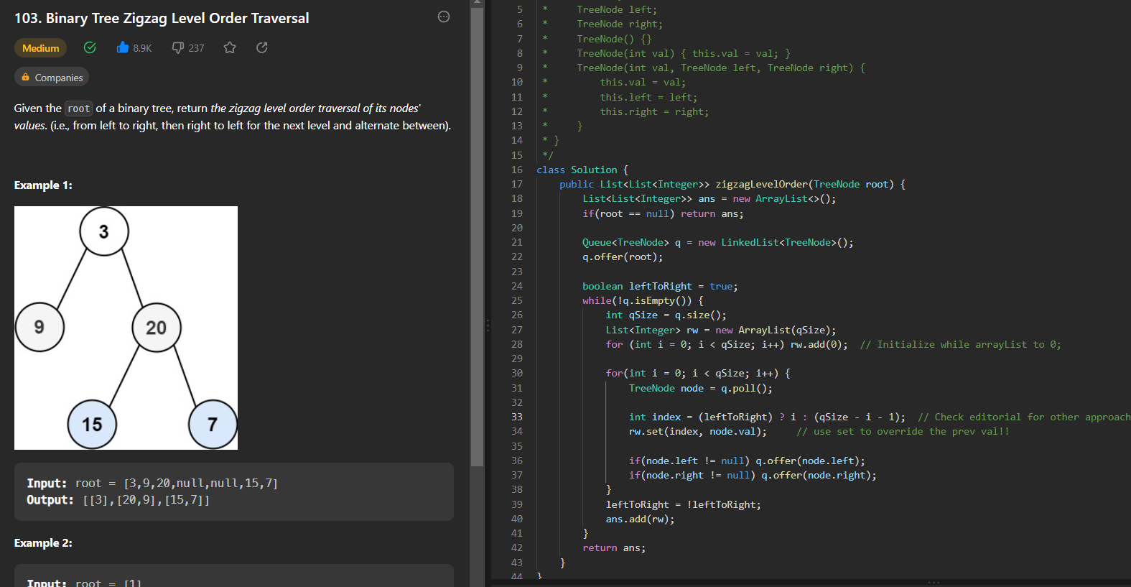

Binary Tree Right Side View

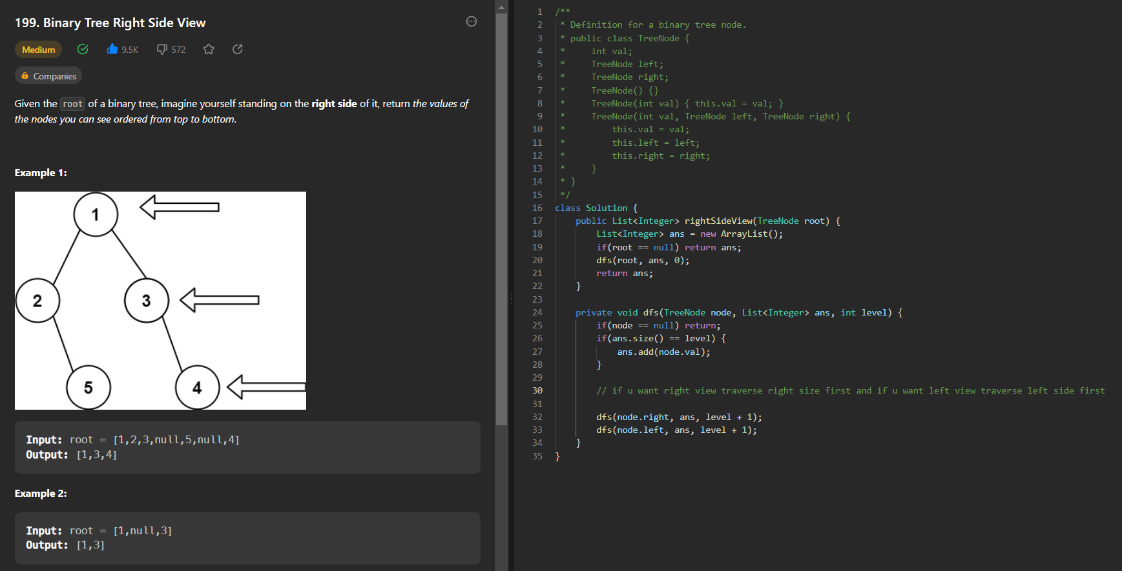
Symmetric Tree

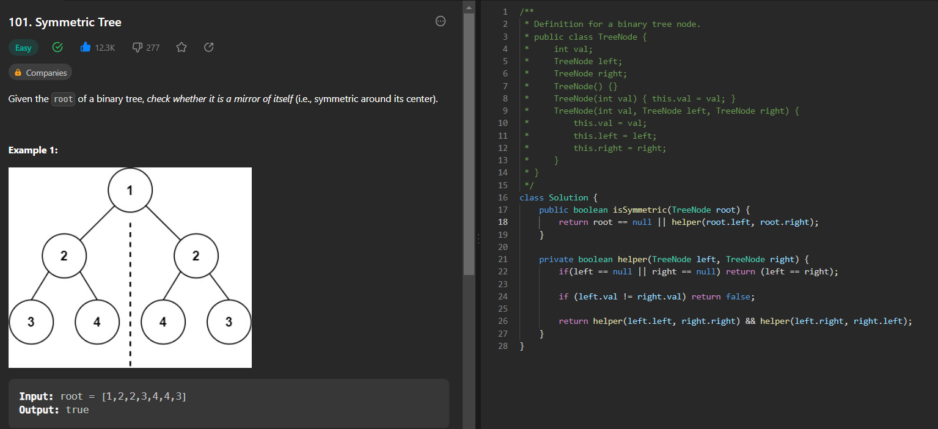

Add two numbers:

TC: O(N) // N is length of longest linked list
SC: O(1) // If we don’t consider the resultant linked list

